**Spike:** Task 11

**Title:** Game Graphs from Data

**Author:** Liam Whitehouse, 103862481

**Goals / deliverables:**

The goal of this spike is to create a Graph Data Map. This Map will have Locations that have their own connections to other location on the map. This will all be loaded in via a text file and displayed and allow the player to traverse through the world.

**Technologies, Tools, and Resources used:**

To create this task, I used Visual Studios and Draw.IO. I designed a rough layout of how the classes would be interconnected and then started creating it.

**Tasks undertaken:**

Starting with Draw.IO, I created a very simple diagram to help visualize what I was going to do.

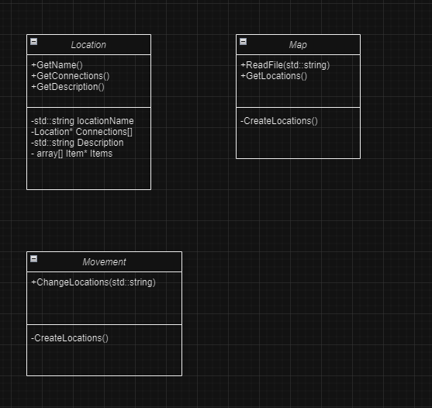

It is not much but it helped get me started on the functions and variables required for making this work.

Next, I started to implement this system. I first started by creating a Locations Class which holds all the information about any given location such as its name, description, connections and eventually Items!

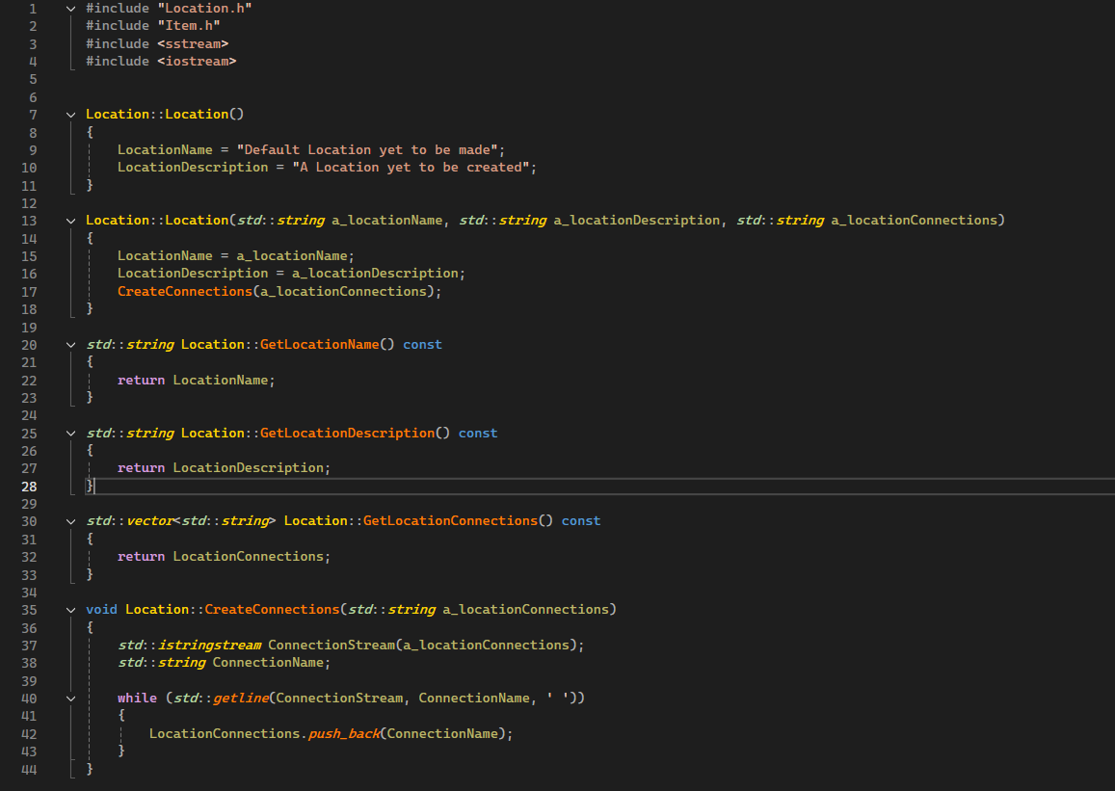

Once the locations were in and working, I next worked on the Map. This was a sizable undertaking as the Map needs to load all locations that will exist, as well as their data from a text file. I struggled a little on this but in the end, I was able to have the map Generate each location from the Text File with their description and Connections.

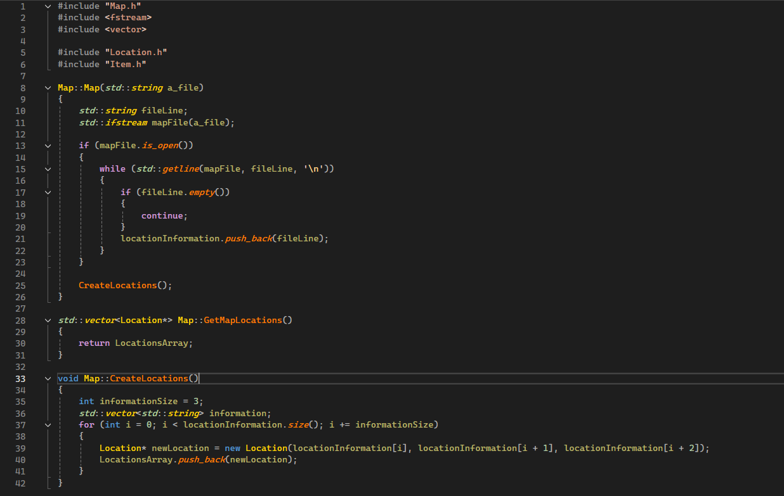

Finally, was Movement, this is still a work in progress, but the basic commands are in for walking and looking, the player’s location changes if they walk to a connecting location.

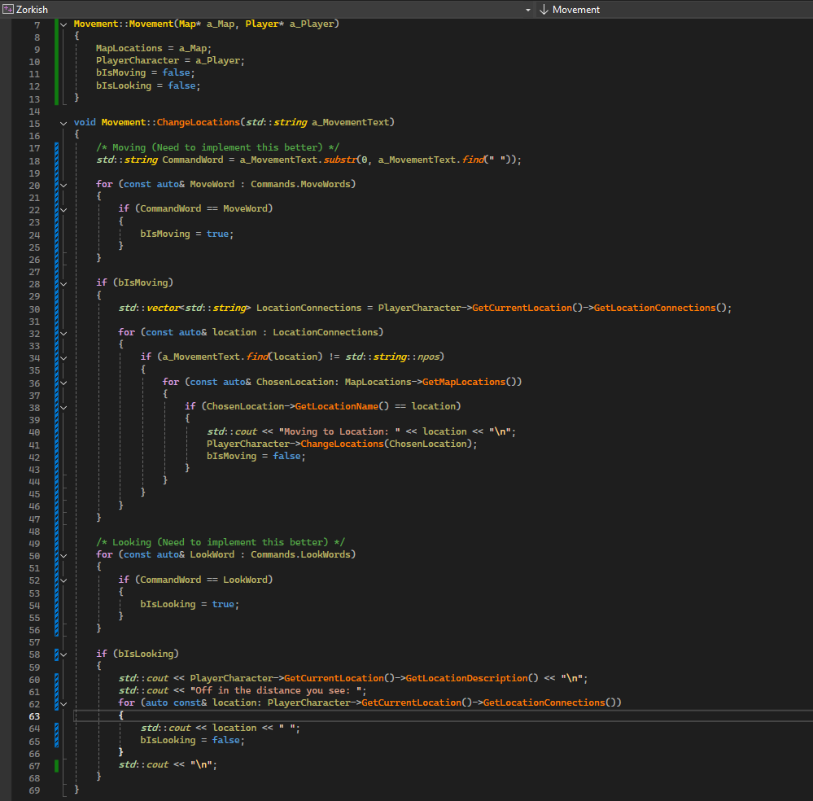

**What we found out:**

This was quite challenging to setup and I still need to refine the Movement Class to make it be more flexible, test out more scenarios but in terms of functionality it performs the required tasks.